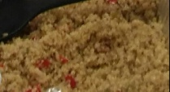
Ingredients:
Quinoa- 1 pkg, Red & Green Peppers-Small Diced= 1Cup. Scallions- 2 stalks White portion only, set aside green tips. Low/No sodium Vegetable Broth 3 Cups, Light extra virgin olive oil 2 Teaspoons
Equipment:
Pot for Boiling, Skillet, Small Net Strainer, Bowl with cover or Aluminum Pan with lid, measuring cup
Preparation:
This Brand of Quinoa requires rinsing first, some packages come pre-rinse. Place 3 cups of broth to boil over a medium fire add quinoa and stir check frequently for 10-15 minutes. Check texture, when desired texture is reached pour quinoa in strainer and let sit for 10-15 minutes
Meantime
Add 2 Tablespoon of olive (enough to coat the skillet), add diced peppers and scallions white portions only and sauté for 3-4 minutes then remove from heat.
Pour quinoa into a bowl or pan spread open with a spoon, add ingredients from skillet lightly mix. Serve and top with the green tips of the scallions.
Suggestions
You can add ginger, fresh garlic and even sofrito to your skillet Caution: add these ingredients in the last 2 minutes before removing skillet from heat because these ingredients can burn quickly and ruin the meal.
Make a Healthy Salad - Put romaine lettuce or spinach in a bowl add diced cucumbers ½ cup 4 cherry/grape tomatoes cut in ½ with sliced fruit like 2 strawberries cut in half

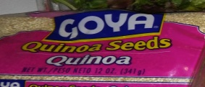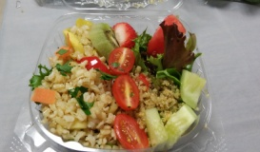 Sample Salad with Quinoa and Brown Rice

Nutrition Facts
Serving Size 1 Serving Per Serving % Daily Value*
Calories 261 Calories from Fat 92
Total Fat 10.3g 16% Saturated Fat 1.3g 7% Polyunsaturated Fat 0.1g
Monounsaturated Fat 7.3g Cholesterol 1mg 0% Sodium 300mg 13%
Potassium 83mg 2% Carbohydrates 34.2g 11% Dietary Fiber 5.9g 24%
Sugars 11.2g Protein 3.5g
Vitamin A 15% · Vitamin C 63%
Calcium 8% · Iron 12%
*Based on a 2000 calorie diet
GOOD POINTS
Very low in cholesterol
Very high in vitamin C

